1. to demonstrate remainder operator

#include <iostream>

using namespace std;

int main()

{

int a, b;

cout << "Enter 2 integers : ";

cin >> a >> b;

cout << "a = " << a << " b = " << b <<endl;

if(b == 0)

{

cout << "Error - division by 0 " << endl;

exit(0);

}

cout << "a % b = " << a % b << endl;

cout << "b % a = " << b % a << endl;

return 0;

}

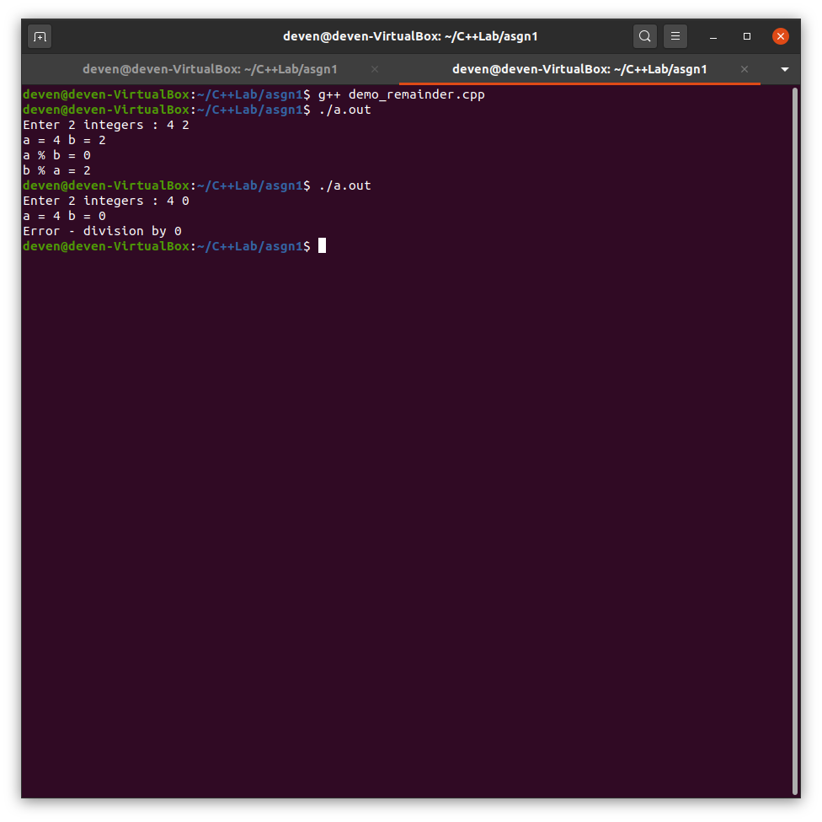

1. to find sqrt of a number

#include <iostream>

#include <cmath>

using namespace std;

int main()

{

double a;

cout << "Enter a number : " << endl;

cin >> a;

cout << "Square root of " << a << " = " << sqrt(a) << endl;

return 0;

}

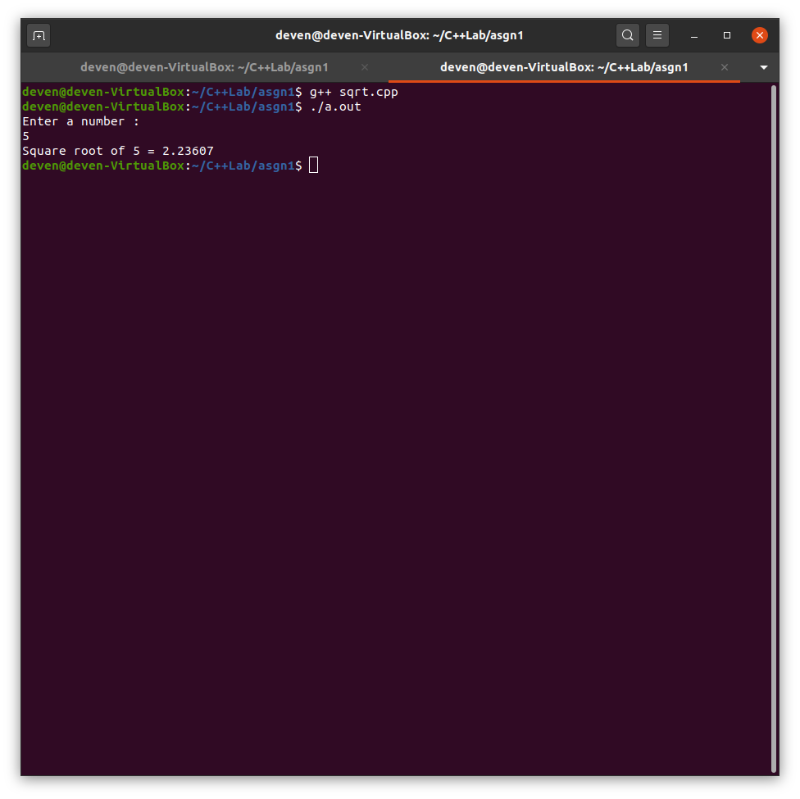

1. A person is at location (10,10), moves stepwise to directions based on (N, W, E, S). If the person reaches location (7,11) treasure is found, at location (5,11) a maneater is found . Use a switch case.

#include <iostream>

using namespace std;

int main()

{

int x=10,y=10;

char direction;

cout<<"The person is at (10,10)"<<endl;

while(true)

{

cout<<"Enter the direction in which person moves(N,E,W,S) : ";

cin>>direction;

switch(direction)

{

case 'N':

y++;

break;

case 'E':

x++;

break;

case 'W':

x--;

break;

case 'S':

y--;

break;

default:

cout<<"Wrong input"<<endl;

}

cout<<"The person is at ("<<x<<","<<y<<")"<<endl;

if(x==7 && y==11)

{

cout<<"The person found the Treasure"<<endl;

break;

}

if(x==5 && y==11)

{

cout<<"The person was eaten by the Maneater"<<endl;

break;

}

}

return 0;

}

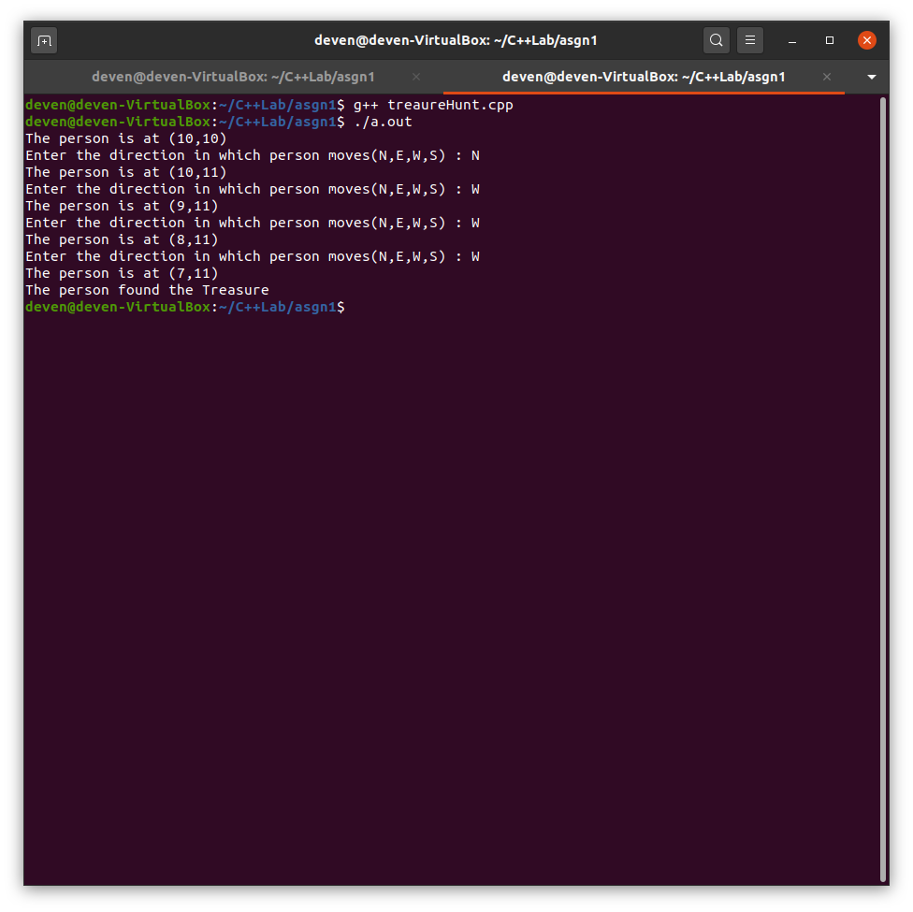

1. Consider two structures : Distance (feet and inches) and Room(length and width). For a dining room instance, calculate the area in square feet.

#include <iostream>

using namespace std;

struct Distance

{

int feet;

float inch;

};

struct Room

{

Distance length;

Distance width;

};

int main()

{

Room dinning;

float total_length,total_width;

cout<<"Enter the length in feet and inch"<<endl;

cin>>dinning.length.feet>>dinning.length.inch;

cout<<"Enter the width in feet and inch"<<endl;

cin>>dinning.width.feet>>dinning.width.inch;

total_length=dinning.length.feet+dinning.length.inch;

total_width=dinning.width.feet+dinning.width.inch;

cout<<"The area of the room is "<<total_length*total_width<<endl;

return 0;

}

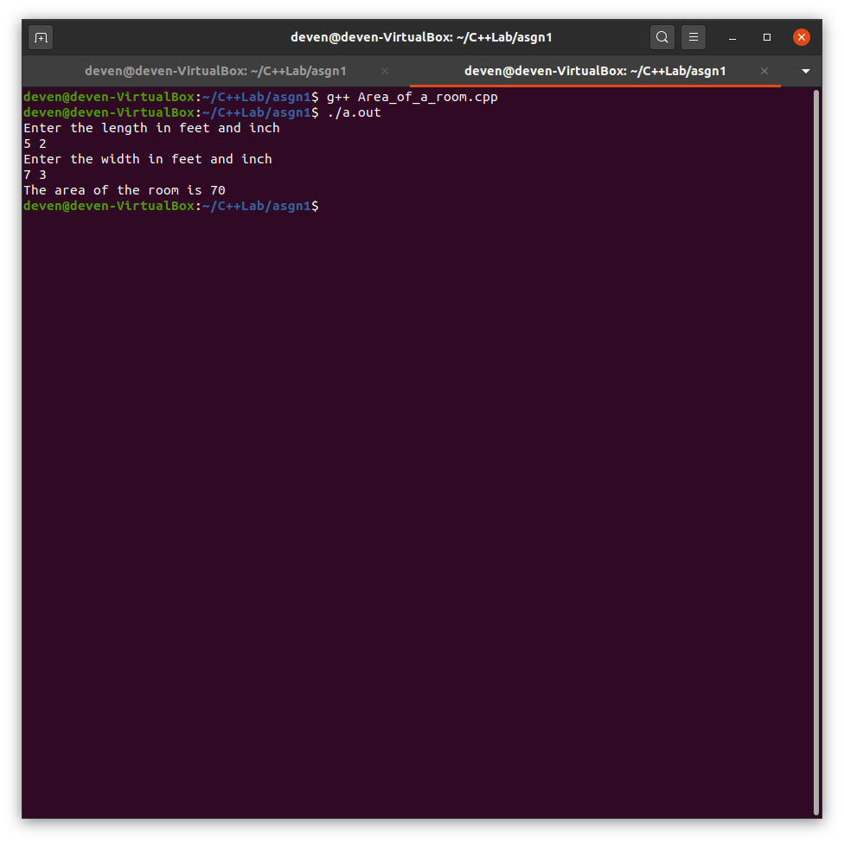

1. Create a structure circle, with suitable attributes and functions, assume (functions name only) different colors to draw the circle, and fill the circles [semi, full, void].

#include <iostream>

#include <string>

using namespace std;

struct point

{

int x;

int y;

};

struct circle

{

point center;

float radius;

float area;

string color;

string fill;

circle(point p,float r,string clr,string fi)//the variable names of classes(like string) used in the structure can't be used here as parameters, eg string color can't be used as a parameter, so changed to string clr

{

center=p;

radius=r;

area=3.14*r*r;

color=clr;

fill=fi;

}

};

int main()

{

circle c1({1,2},2,"blue","full");//if we were doing c1={{1,2},2,"blue","full"},i.e normal struct initialization, it wouldn't work coz, in that we have to pass all the arguments, i.e area value also we have to pass

circle c2({2,4},3,"red","semi");

cout<<"Circle 1 details : "<<endl;

cout<<"center = ("<<c1.center.x<<","<<c1.center.y<<")"<<endl;

cout<<"radius = "<<c1.radius<<endl;

cout<<"area = "<<c1.area<<endl;

cout<<"color = "<<c1.color<<endl;

cout<<"fill = "<<c1.fill<<endl;

cout<<"Circle 2 details : "<<endl;

cout<<"center = ("<<c2.center.x<<","<<c2.center.y<<")"<<endl;

cout<<"radius = "<<c2.radius<<endl;

cout<<"area = "<<c2.area<<endl;

cout<<"color = "<<c2.color<<endl;

cout<<"fill = "<<c2.fill<<endl;

return 0;

}

